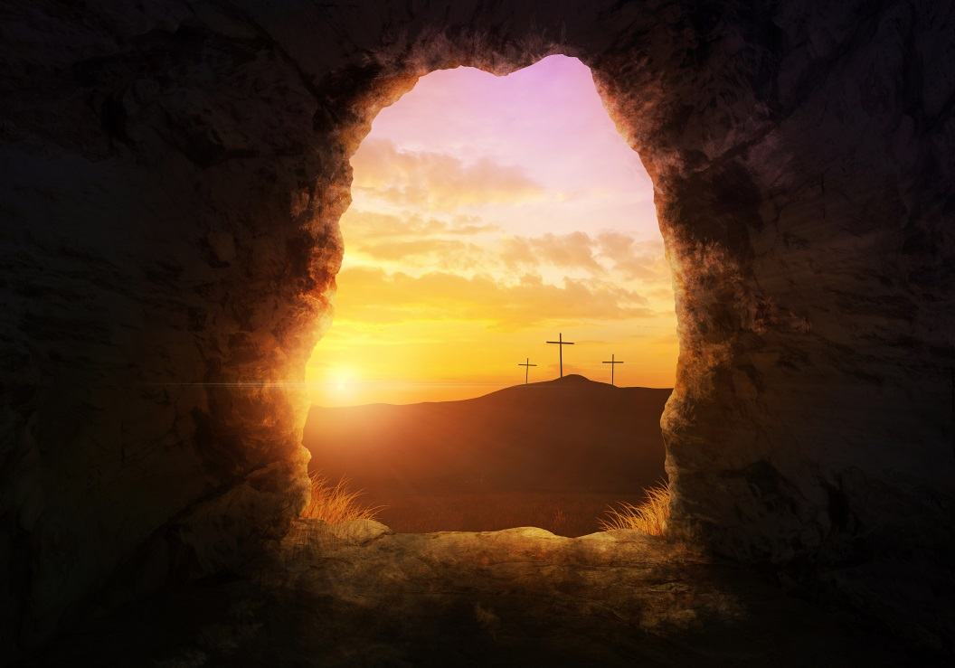
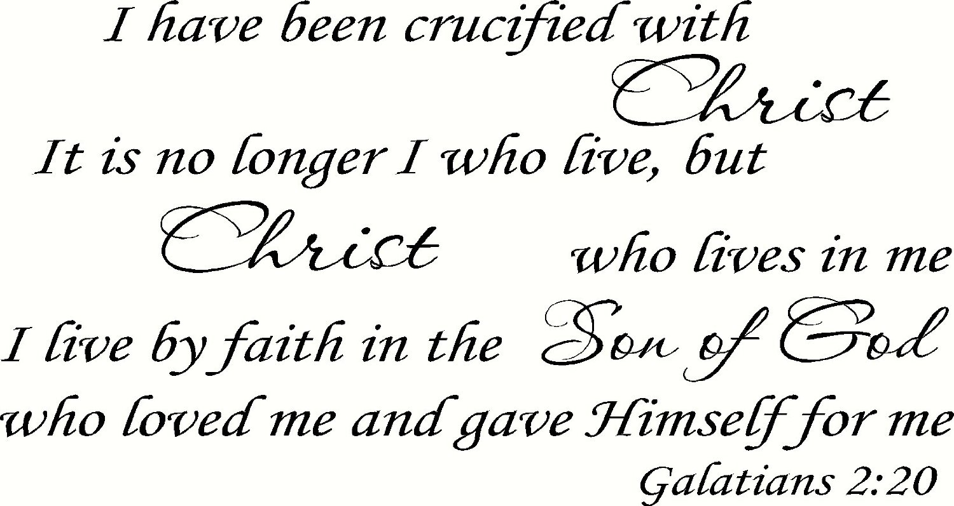
THE THEOLOGY OF THE CROSS
At the crucifixion of Jesus they offered Him wine to drink mingled with gall. He refused to drink their distilled damnation; He refused to imbibe of their liquid fire. At best or at worse you might say the Lord turned down their social drink. No wonder they continued with the crucifixion; our Lord Jesus was a party pooper. There isn't anything that makes a gathering of people any more upset than to turn down their booze. He would not take anything that would dull His senses in the matter of suffering for our sins. So they drove their nails through His hands, it was at this time that He said, "Father forgive them for they know not what they do." This was not carte blanche forgiveness on the spot unless we can say there is forgiveness without repentance.
The soldiers took the garments of Jesus and divided them among them. They cast lots for the seamless robe of the Master: gamblers at the foot of the cross. Many gamble today with higher stakes than were ever bet in the gambling casinos.
Pilate wrote a title and put it upon the cross: This Is Jesus The King Of The Jews. Everybody could read it since it was written in Hebrew, Latin and Greek. The Jews said, "Write not the King of the Jews but that He said I am the King of the Jews." It was customary to put the charge against a criminal on the cross. An appropriate sign would have been a sign that contained all of my sins. That is the reason that Jesus died. Because of computers we can understand how God could give a read out of all our sins and hang them on the cross. Considering the thousands of impressions that can be contained in a computer. If all our sins could be computerized (and they are) there could have been an instant read out of our sins placed on the cross that day. The description of the crucifixion in Matthew and Mark is that they railed on Him as they passed by and taunted Him "If thou art the Christ come down from the cross, He saved others Himself He cannot save." No truer words were ever spoken than this. He could not save Himself and save us at the same time. Mark adds this thought when he states that they said HA. They laughed at the Lord on the cross. We are in good company today when they laugh at our ignorance our stupidity for faith in the Word of God.
Even the two thieves rebuked the Lord. One of them said, “Art thou not the Christ save thy self and us." Get yourself off the cross and us too we will make a run for it. The other thief later said, "Lord, remember me when thou comesth into thy Kingdom." Many today speak of being saved like the thief on the cross. To do this you would have to have lived before Jesus died on the cross and before He arose from the dead. Jesus told him, "Today you shall be with Me in Paradise." Did Jesus ever tell you that? When we ask what to do he gives us a somewhat different answer.
During the agony on the cross Jesus saw His mother and the Apostle John standing there. He said to His mother, "Behold thy son," and to that disciple, "Behold thy mother." According to some perhaps He should have said, "Wait around for a while, Joseph of Arithmathea, will be here before long and I will commend you to his care he is rich. He has a four or five bedroom house, five bathrooms a five car garage, he can take care of you a lot better than this poor disciple of mine who has given up his fishing business to follow me.
About the sixth hour there was darkness over all the earth until the ninth hour. At about the ninth hour was when Jesus said with a loud voice, "Eli Eli Lama Sabacthani." Some thought that He was calling for Elijah. Some said, "Let us see if Elijah will come to save Him." In most stories of fiction the hero always arrives at the last moment to rescue the victim. If they thought that Elijah would arrive that day in a fiery chariot they were mistaken. The real Hero was on the cross. Jesus is my Hero; He saves me from hell fire.
After this is when Jesus cried, "I thirst," and they brought a sponge full of vinegar to His mouth. Upon the receiving of the vinegar He said, "It is finished," and bowed His head saying, "Father into thy hands I commend My spirit." And this is a sketch of what happened when they came to a place called the place of the skull, Golgotha or Calvary.
The reason we call this message "THE THEOLOGY OF THE CROSS" is because this story would be a good starting place for any kind of a sermon you might want to preach or any kind of a lesson you might want to teach. The proclamation of what happened at Calvary is a story that is relevant to any situation in the Bible from Genesis to Revelation. Without the cross nothing else matters. Consider first a sermon on the giving of money.
GIVING
Suppose a preacher is working on a message on the giving of money. What better place to start than at the cross. How about the verse God so loved the world that He gave His only begotten Son that whosoever believeth on Him should not perish but have everlasting life. That statement about the gift of God underscores the oft repeated statement, "You cannot out give God." So look at what God gave. Look at what Jesus gave. The cross is a measuring stick to gage our own giving. The cross makes the question, "Do I have to tithe?" sound stupid. No, you don't have to tithe. You don't have to give nine percent. You don't have to give five percent. You don't have to give one percent. You don't have to give anything. A person's pocketbook also becomes a measuring stick to measure the distance from your heart to Jesus as He suffers on the cross for you. You cannot separate your possessions from the cross of Calvary. This is the Theology of the Cross. Again think of a sermon on the subject of baptism.
BAPTISM
Suppose you hear a message on baptism. Is it not a good thing to start at the cross? Paul said, "As many of us as were baptized into Christ were baptized into His death." The baptismal ordinance is tied to the cross. The baptism is a reenactment of what happened at Calvary. When we stand in the water our bodies stiffen just like in death. Our eyes close just like in death. We stop breathing just like in death. And then like a burial we were buried by the power of someone’s else’s arms. We were completely covered up just like a burial. Then we were raised up by the power of another just like a resurrection. Our eyes opened just like a resurrection. And we began to walk in a newness of life just like it will be in the resurrection. Immersion provides a perfect picture of what happened at Calvary. You cannot preach baptism without preaching about the sacrifice of Jesus at Calvary. Suppose you were preaching a message on the Lord's Supper.
THE LORDS SUPPER
How can a preacher preach a message on the Lord's Supper without the cross? Especially when Paul said, "As oft as ye do this ye show forth My death till I come." The showing forth of the death of Christ is one of the reasons for the Lord’s Supper. Many people will put other thing ahead of the Lord’s Supper on the Lord's Day and the reason is they have nothing to show. Ye show forth the Lord's death till He comes. An old axiom in show business is “The show must go on.” In the King James Version, ye show forth His death. For the Christian it is true, THE SHOW MUST GO ON. Ladies and gentlemen, that is the Theology of the Cross.
THE SECOND COMING.
Remember the first chapter of Revelation when the Apostle said, "Behold He cometh with the clouds and every eye shall see Him yea and they that pierced Him and all the tribes of the earth shall mourn over Him even so Amen." One of the dominant characteristics of the Second Coming of Jesus will be that every eye shall see Him and recognize Him as the one who was crucified. They will mourn over him because they have rejected His blood. The song says it well for us as Christians.
I shall know Him I shall know Him;
And redeemed by His side I shall stand
I shall know Him I shall know Him;
By the print of the nails in His hands.
At the Second Coming He will be recognized as the crucified one and this is the Theology of the Cross.
THE CHURCH
Again we state that the crucifixion is paramount in Church doctrine. When the Apostle Paul gathered the elders of the Church at Ephesus together at Miletus he gave them farewell instructions on their behavior as elders. One thing he said was in regards to the origin of the Church, he said, "Take heed unto yourselves and to all the flock over which the Holy Spirit hath made ye our bishops to feed the Church of God which He purchased with His own blood." God the Son is the one who gave His blood. You cannot preach or teach about the Church without being reminded of the cross.
One preacher told me of a man in his community who shot his wife and then turned the gun on himself. Two teenage children who were members of the church were called home. The preacher who was summoned to the scene saw them coming and rushed out into the yard and held up his hands to stop them from coming it at that time. The son of the dead parents saw the blood on the preacher’s hand and said, “Brother Joe, is that my daddy’s blood on your hands?” That preacher told me he felt the cold chills run up his spine. You cannot separate the Church from the blood of Christ. He bought and paid for it at Calvary and that is the Theology of the Cross.
THE JUDGEMENT DAY
In speaking of the Judgment day we note that Paul links it up with the cross. Remember how he spoke to the Athenians on Mars Hill and told them that God had appointed a day in which He would Judge the world in righteousness by that man whom He hath ordained whereof He hath given assurance unto all the nations in that He hath raised Him from the dead.
According to Paul there is some connection between the raising of Jesus from the dead and His appointment to judge the human race. During the days of World War Two, Adolph Eichmann was responsible for killing six million Jews. When he was brought to trial and found guilty he was sentenced to be hanged. The reporters met with him to get a statement before he was executed. I remember reading the account in the paper. The last thing that Eichmann said to the reporters as they left him was, "Gentlemen, I'll be seeing you." Eichmann evidently knew where he was heading. He was going to appear before another judgment bar the judgment bar of God. The judgment bar presided over by Judge Jesus. Jesus who has been as Paul said ordained to this position by virtue of the fact that He was raised from the dead. Therefore any sermon that we preach or any lesson that we teach on the day of Judgment must take into consideration the crucifixion of the Lord and that is the Theology of the Cross. Then again we must consider that the same thing is true should we decide to preach a message on the matter of the inspiration of the scripture.
INSPIRATION OF THE BIBLE
At the account of the Great Commission of Jesus to the Apostles in the book of Luke Jesus told the Apostles regarding His death and resurrection, "These are My words which I spake unto you while I was yet with you, that all things must needs be fulfilled which are written in the law of Moses and the Prophets and the Psalms concerning Me." According to Jesus He regarded the writings of the whole Old Testament as inspired. He said that these prophecies made by Moses; David and all the prophets have been fulfilled—these prophecies regarding His crucifixion and His resurrection. So when you speak of the inspiration of the word of God this statement regarding His sacrifice must be considered. You cannot talk about the inspiration of the Bible without considering the sacrifice of Jesus and that is the Theology of the Cross. And now let us apply this same principal to Christian living.
THE CHRISTIAN LIFE
Paul says in the sixth chapter of Hebrews, "For as touching those who were once enlightened and tasted of the heavenly gift and were made partaker of the Holy Spirit and tasted the good word of God and the power of the age to come and then fell away it is impossible to renew them again to repentance seeing that they crucify to themselves the Son of God afresh and put Him to an open shame.”
The crucifixion is thereby tied to the Christian’s life style. When we fall away we crucify the Son of God afresh. According to some once you are saved you can never be lost. But Paul says you can and I believe Paul. Your whole life as far as your faithfulness is concerned is tied into the crucifixion and that is the Theology of the Cross. And now one more it is equally true that the crucifixion is related to prayer.
PRAYER
In the first epistle of John the second chapter John tells "And if any man sin, we have an advocate with the Father, Jesus Christ the righteous: And He is the propitiation for our sins; and not for our sins only but also for the whole world."
We have a lawyer, an advocate with the Father. I went into a Barbershop and saw a man laid back in the chair. His face was lathered up for a shave. He looked up and saw me coming in and said, “I will tell you how it is. When you die, if you have a good mouthpiece at your funeral you will make it.” He mentioned the name of his favorite preacher and said if he will preach my funeral I will make it to heaven and then I suppose to be polite he said, “Or if you do it, Ed, I’ll make it.” He was right as far as needing a good mouthpiece is concerned; the only thing is he had a couple of shysters for lawyers. The only one who can plead your case before God is Jesus. If you retain Him for your defense you will make it. He has never lost a case. He is our advocate with the Father. Jesus Christ the righteous, He is the One who pleads our case before God. The reason He can plead our case is because He is our propitiation; the wrath of God against our sins has been removed. He paid the price for us. God will hear our prayers through Jesus by virtue of the fact that He died in our place. So you see we can’t even pray to the Father without thinking about the crucifixion. Because of the death of Christ on the cross God the Father is willing to listen to us. That is the Theology of the Cross.
Some might say that it is not good homiletics to bring in the Cross and the plan of salvation to a sermon from Ezekiel or one of the other prophets. I never let homiletics interfere with my preaching and the salvation of those who are lost and going to hell. To leave out these important matters is an exercise in futility. The story of Calvary, Golgotha, the place of a skull and the proper response to that message must be brought into every message when the lost are listening. This is THE THEOLOGY OF THE CROSS. (From 2007 archive of EB)
Were you there when they crucified my Lord?
Were you there when they laid Him in the tomb?
Were you there when He rose up from the grave?
Sometimes it causes me to tremble, tremble, tremble.
++++++++++++++++++++++++++
LETTERS
I used to receive your Bible Studies when I was in prison last year. I am now in a 2-year Behavior Modification Treatment Facility; and I would like to start doing your Bible Studies again. My name is Amanda. My new address is below. Please send me more Bible Studies. Sincerely Amanda from Deer Park, TX
++++++
Dear Brother in Christ, I was just talking with a new Christian Brother that told me about your wonderful program you have for providing indigent prisoners with Bibles. What alessingit would be if I could receive a Giant Print Bible. Im unable to see any small print because of a serious eye disorder. Thank you so much for what you are doing to help spread His word to people in need. Robert, Ramsey I Unit, Rosharon, TX
++++++++++++++
Thank you for all your input and information. It’s so wonderful to be a part of the “Jesus Club” here in Prison at Shreveport, LA. Phillip.
I really enjoy your Bible Study and I am grateful for your help in my walk of faith. Thanks for your time and the beautiful Bible. God bless! Robert from Galveston, TX.
My father, Charles B. is pastor of a Church of Christ in AR. I would like for you to send him your newsletter—his address blow. I am already on your mailing list and still in prison at Wrightsville, AR.
I’m writing this letter because I’m in Montgomery County Jail, Conroe, TX. I am facing 50 years to life. I have a really good neighbor who is next door to me and had given me this address through the goodness of the Lord. Please send me a big print KJV Bible and Bible Study lessons. Thank you Gordon.
I hope this letter finds you all in good health. I am writing so I can thank you for the Bible and Bible Studies they are read every day. The large print bible sue helped so much because I have only one eye and it was so hard for me to rad the one here. Your friend for life. James from Plain Dealings, LA.
Dear Naomi, I’m, writing this letter to thank the Ed Bousman Ministry for the Bible and studies that y’all sent me when I was in Jail. Well, I’m no longer locked up and I’m very thankful that our heavenly Father has helped me through my struggels in life. I have learned to let go and let God in in my life and I know that He will lead me on a good path. God has given me so much understanding through your studies and now I see life in a whole new meaning. Keep me and my family in prayer and if there are any more studies please send me more. Thanks for the monthly newsletter and I wish I could thank you personally. May God continue to bless your ministry. Anthony from Elgin, TX. (He has completed four of our 10 available studies. I’ll send next set of lessons to him.)
GIJAPA Family, I have been a member of GIJAPA for nearly two years. I am in my 32nd year of physical prison bars. Until recently I never ever sent money you or anyone. I’m not stingy, I just never sent money to people on the outside. God spoke to my heart and I sent $3.00 (10% of my pay to you). For this, God returned two good pairs of shoes and a promise. I then sent $3.26 (10% again), for this God gave me a pay rise of $15, a $50 holiday gift and extra work for a total of $133, for the month of December. I sent GIJAPA $13.37. In January I have already made $97 and stand to make another $145 in extra work! It will be my highest tithe ever, nearly $25. Praise God. Tithing rewards it is promised by God in Malachi and Luke. He says “Try me on this. . . “ To all who read this letter, try God on His promise. Just 10% of any money you get. DO NOT CHEAT YOURSELF! Get ready to reap a bountiful harvest. Charles from Welch, WV.
LETTERS from Listeners of SW broadcasts:
Dear God Is Just A Prayer Away: May the Lord continue to bless this noble programme to Radio Africa for its immense contribution to the salvation of mankind. Many are blessed through this ministry and I thank the Almighty God for bringing us closer to Him through your broadcast messages. Thank you and God bless you. In Christ Nicholas B. from Kumas, Ghana W. Africa.
Dear Evangelist Ed Bousman: greeting to you all in the name of our Lord Jesus Christ who died for our sins and gave salvation to all mankind. I am grateful to Jesus Christ for using Saints to win souls and also am happy for your accepting the gospel of Christ and you are still passing it through to win souls for Christ. I heard of your good works from yhour programs on Radio Africa and of how you went through all kind of hardship but never have you given up or stop preaching the good news. May the Lord keep you strong to the end bless you. Amen. Yours faithfully Lydia from Jos Plateayu State, Nigeria.
Dear Beloved Sister Naomi and Family: Holy greetings in the most precious name of our Lord and savior Jesus Christ, by whose grace we are O. Kay and do hope the same with you all. Thank you very much for your love and prayers for our ministry in India. We do very much thankful to you for your kind prayer support. I am keeping on asking you for the clothes so a long back since I have sent to you the details of the ages and genders. Please kindly send the needed clothes as the Lord leads you. I an continuously receiving the GIJAPA newsletter each month and we are encouraged through reading of this paper. We are encouraged through your radio ministry that comes to us from Sri Lanka, India each Sunday morning at 8:30. We continue to pray for you and the work you are doing here in India. With much love and prayers, yours in His service Alphonse from Calvary Church of Christ in Srikakulam, India.

